

“Expert Cloud Consulting” - SOP | Monitoring and logging
03.January.2025 version 1.0
—
Contributed by Tejal Kale Approved by Akshay Shinde Expert Cloud Consulting
Office #811, Gera Imperium Rise,
Hinjewadi Phase-II Rd, Pune, India – 411057

“Expert Cloud Consulting”
Monitoring and Logging

Contents
- Contents 1
- General Information: 2
  - Document Purpose 2
  - Document Revisions 2
- Document Overview 3
- Project Overview 4
  - Architecture 4
  - Prerequisites 4
  - Project Structure 4
- Product Service (Python/Flask) 5
  - Application Setup 6
  - Requirement.txt 6
  - Dockerfile 6
  - Templates/index.html 6
  - Static/style.css 7
- Order Service (Node.js) 7
  - Package.json 7
  - Server.js 7
  - Dockerfile 8
- Database Setup (MySql) 8
  - db/init/sql 9
- Docker Compose Configuration 9
  - docker.compose.yml 9
- Running Apllication 10



General Information:

Document Purpose

This document serves as a detailed roadmap for organizations looking to migrate their databases from Azure to AWS. It includes best practices, AWS migration tools, and step-by-step instructions to ensure a successful migration with minimal downtime and optimal performance.

Date | Versio n | Contributor(s) | Approver(s) | Section(s) | Change(s)
03/Jan/2025 | 1.0 | Tejal Kale | Akshay Shinde | All Sections | New Document Created

Document Overview:

This document provides a step-by-step guide for migrating databases from Microsoft Azure to Amazon Web Services (AWS) using AWS Database Migration Service (AWS DMS). It covers migration strategies, tools, and best practices to ensure a smooth, secure, and efficient transition of databases from Azure to AWS.

1. Install Docker & Docker Compose
Step 1: Install Docker

sudo apt update && sudo apt upgrade -y
sudo apt install -y docker.io
sudo systemctl start docker
sudo systemctl enable docker

Verify Docker Installation
docker –version

Step 2: Install Docker Compose
sudo curl -L "https://github.com/docker/compose/releases/latest/download/docker-compose-$(uname -s)-$(uname -m)" -o /usr/local/bin/docker-compose
sudo chmod +x /usr/local/bin/docker-compose
docker-compose --version

2. Create a Simple Python Application with Metrics
We will create a simple Flask application with Prometheus instrumentation to expose metrics

Step 1: Create a Project Directory
mkdir monitoring-app && cd monitoring-app

Step 2: Create app.py
nano app.py
Paste the following code:
from flask import Flask, Response
from prometheus_client import Counter, generate_latest

app = Flask(__name__)

# Create a Prometheus counter metric
REQUEST_COUNT = Counter('http_requests_total', 'Total HTTP Requests')

@app.route('/')
def home():
REQUEST_COUNT.inc()
return "Hello, World!"

@app.route('/metrics')
def metrics():
return Response(generate_latest(), mimetype='text/plain')

if __name__ == "__main__":
app.run(host="0.0.0.0", port=8080)

This application:
- Serves a simple homepage (/)
- Exposes Prometheus metrics at /metrics
- Tracks the total number of HTTP requests

Step 3: Create a Dockerfile
This builds a Python image with Flask and Prometheus client libraries.

nano Dockerfile

Paste the following code:
FROM python:3.9
WORKDIR /app
COPY app.py .
RUN pip install flask prometheus_client
CMD ["python", "app.py"]

Step 4: Build & Run the Application in Docker

docker build -t my-flask-app .
docker run -d --name flask-app -p 8080:8080 my-flask-app
Now, check if metrics are available:
curl http://localhost:8080/metrics

3. Set Up Prometheus & Grafana Using Docker Compose

Step 1: Create a prometheus.yml Configuration File
nano prometheus.yml
Paste the following configuration:
global:
scrape_interval: 5s # Collect metrics every 5 seconds

scrape_configs:
- job_name: 'prometheus'
static_configs:
- targets: ['localhost:9090']

- job_name: 'flask-app'
static_configs:
- targets: ['flask-app:8080']
Prometheus is now set up to monitor:
- Prometheus itself (localhost:9090)
- Flask application (flask-app:8080)

Step 2: Create an alert_rules.yml File for SLA Violations
nano alert_rules.yml
Paste the following alerting rules:
groups:
- name: SLA Alerts
rules:
- alert: HighRequestRate
expr: rate(http_requests_total[1m]) > 5
for: 2m
labels:
severity: critical
annotations:
summary: "High request rate detected!"
description: "More than 5 requests per second received for 2 minutes."
This alert triggers when more than 5 requests per second are received.

Step 3: Create docker-compose.yml
nano docker-compose.yml

Paste the following configuration:
version: '3.8'
services:
prometheus:
image: prom/prometheus
container_name: prometheus
volumes:
- ./prometheus.yml:/etc/prometheus/prometheus.yml
- ./alert_rules.yml:/etc/prometheus/alert_rules.yml
ports:
- "9090:9090"
networks:
- monitoring

grafana:
image: grafana/grafana
container_name: grafana
ports:
- "3000:3000"
depends_on:
- prometheus
networks:
- monitoring
environment:
- GF_SECURITY_ADMIN_PASSWORD=admin # Default Grafana password

flask-app:
build: .
container_name: flask-app
ports:
- "8080:8080"
networks:
- monitoring

networks:
monitoring:
driver: bridge

This will start:
- Prometheus (http://localhost:9090)
- Grafana (http://localhost:3000)
- Flask Application (http://localhost:8080/metrics)
4. Start the Monitoring Stack

Run the following command to launch everything:

docker-compose up -d

5. Configure Grafana to Display Metrics

Step 1: Add Prometheus as a Data Source
- Open Grafana → http://localhost:3000
- Login: admin / admin (default credentials)
- Click Settings → Data Sources → Add Data Source
- Select Prometheus
- In the URL field, enter: http://prometheus:9090
- Click Save & Test
Grafana is now connected to Prometheus!

6. Create a Grafana Dashboard for Monitoring
- Click Create → Dashboard
- Click Add a new panel
- Select Prometheus as the Data Source
- Enter a PromQL query (e.g., Request Count):
rate(http_requests_total[5m])
- Click Apply to save the panel.
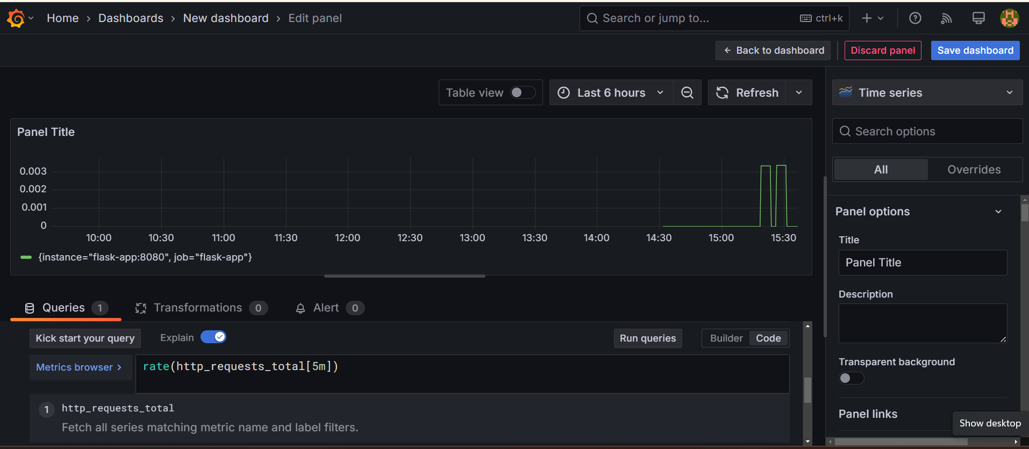

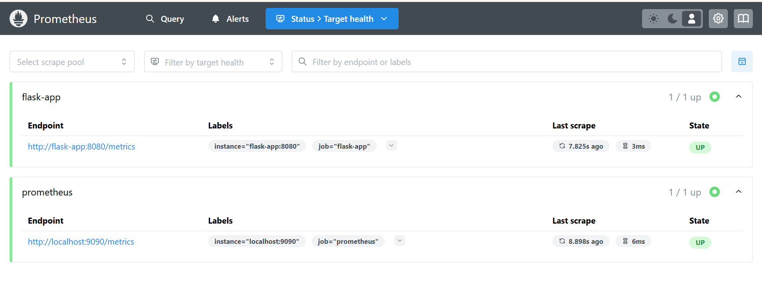
Next Steps: Setting Up Alerts, Notifications & Deployment
Now that Prometheus and Grafana are monitoring your application, let's:
Set up alerts in Prometheus (for high CPU, memory usage, or request rates)
1. Set Up Alerts in Prometheus
Step 1: Create an alert_rules.yml File
nano alert_rules.yml
Paste the following alerting rules:
groups:
- name: SLA_Alerts
rules:
- alert: HighRequestRate
expr: rate(http_requests_total[1m]) > 5
for: 2m
labels:
severity: critical
annotations:
summary: "High request rate detected!"
description: "More than 5 requests per second received for 2 minutes."

- alert: HighMemoryUsage
expr: container_memory_usage_bytes{name="flask-app"} > 500000000
for: 2m
labels:
severity: warning
annotations:
summary: "High Memory Usage"
description: "Memory usage has exceeded 500MB."
This will trigger alerts when:
- More than 5 HTTP requests per second occur for 2 minutes.
- Memory usage exceeds 500MB.

Step 2: Link Alerts to Prometheus Config
1️ Open Prometheus config file (prometheus.yml):
nano prometheus.yml
2️ Add this under rule_files:
rule_files:
- "alert_rules.yml"
3️ Restart Prometheus to apply changes:
sudo docker restart Prometheus
Verify Alerts in Prometheus
1️pen Prometheus: 👉 http://localhost:9090
2️ Click on Alerts

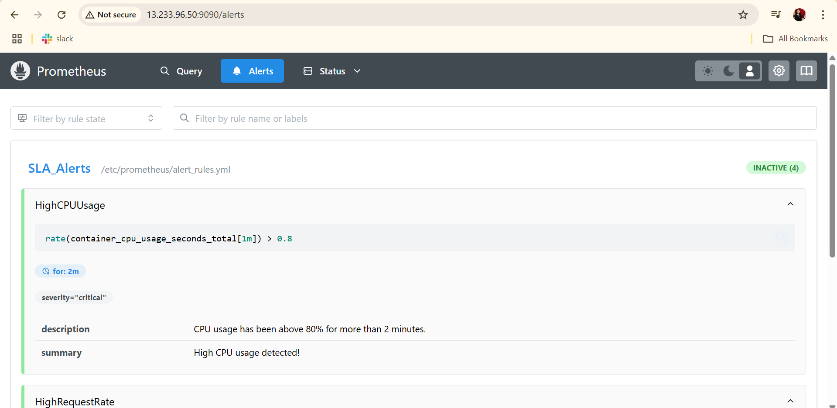

Install & Set Up ELK Stack (If Not Installed)

Install Java (Required for Elasticsearch & Logstash)
sudo apt update
sudo apt install -y openjdk-11-jdk
java -version

Install Elasticsearch

wget -qO - https://artifacts.elastic.co/GPG-KEY-elasticsearch | sudo apt-key add -
echo "deb https://artifacts.elastic.co/packages/7.x/apt stable main" | sudo tee -a /etc/apt/sources.list.d/elastic-7.x.list
sudo apt update
sudo apt install -y elasticsearch

Enable and Start Elasticsearch:
sudo systemctl enable elasticsearch
sudo systemctl start elasticsearch

Install Logstash
sudo apt install -y logstash
sudo systemctl enable logstash
sudo systemctl start logstash

Install Kibana
sudo apt install -y kibana
sudo systemctl enable kibana
sudo systemctl start kibana

Access Kibana:
Open http://your-server-ip:5601 in a browser.

2️ Configure Filebeat to Send Logs to Logstash
Filebeat will collect logs from applications and send them to Logstash, which will process and forward them to Elasticsearch.

Step 1: Install Filebeat
sudo apt install -y filebeat
Enable Filebeat to Start on Boot
sudo systemctl enable filebeat

Step 2: Configure Filebeat to Send Logs to Logstash
1️Open Filebeat configuration file:
sudo nano /etc/filebeat/filebeat.yml

2️ Modify the output section to send logs to Logstash instead of Elasticsearch:
filebeat.inputs:
- type: log
enabled: true
paths:
- /var/log/*.log

output.logstash:
hosts: ["localhost:5044"]

3️ Restart Filebeat
sudo systemctl restart filebeat

3️ Configure Logstash to Process Filebeat Logs

1️ Create a Logstash Pipeline Configuration File
sudo nano /etc/logstash/conf.d/logstash-filebeat.conf

2️ Paste the following configuration:
input {
beats {
port => 5044
}
}

filter {
grok {
match => { "message" => "%{TIMESTAMP_ISO8601:timestamp} %{LOGLEVEL:loglevel} %{DATA:component} - %{GREEDYDATA:message}" }
}
}

output {
elasticsearch {
hosts => ["http://localhost:9200"]
index => "filebeat-logs-%{+YYYY.MM.dd}"
}
stdout { codec => rubydebug }
}
This Logstash pipeline will:
- Receive logs from Filebeat on port 5044
- Parse logs using Grok to extract structured fields
- Send the logs to Elasticsearch under the index filebeat-logs-YYYY.MM.dd
3️ Restart Logstash
sudo systemctl restart logstash

4️ Verify Logs in Elasticsearch

1️ Check if logs are indexed in Elasticsearch:
curl -X GET "http://localhost:9200/_cat/indices?v"
2️ Search logs in Elasticsearch:
curl -X GET "http://localhost:9200/filebeat-logs-*/_search?pretty"
If logs are present, Elasticsearch is successfully receiving logs from Logstash.

5️ Build Visualizations in Kibana
Now that logs are flowing into Elasticsearch, let’s create Kibana visualizations for error trends.

Step 1: Open Kibana UI

- Go to http://your-server-ip:5601
- Click "Stack Management" → "Index Patterns"
- Click "Create Index Pattern"
- Enter filebeat-logs-* and click Next
Step 2: Create an Error Trend Dashboard

- Click "Visualize" → "Create Visualization"
- Select Line Chart
- Choose the filebeat-logs- index*
- Configure the X-axis to use @timestamp
- Configure the Y-axis to show the count of error logs (loglevel: ERROR)
- Click Save Dashboard
- 